Exp 9

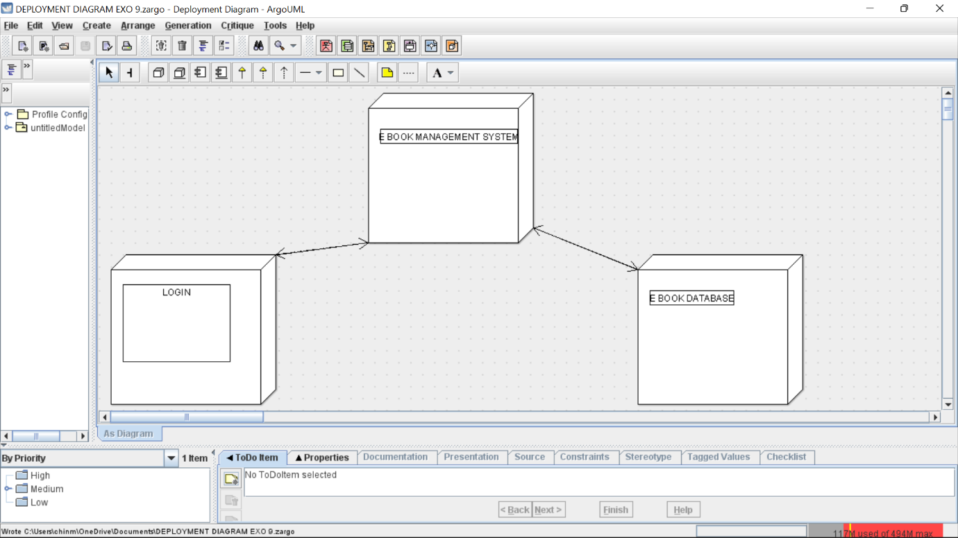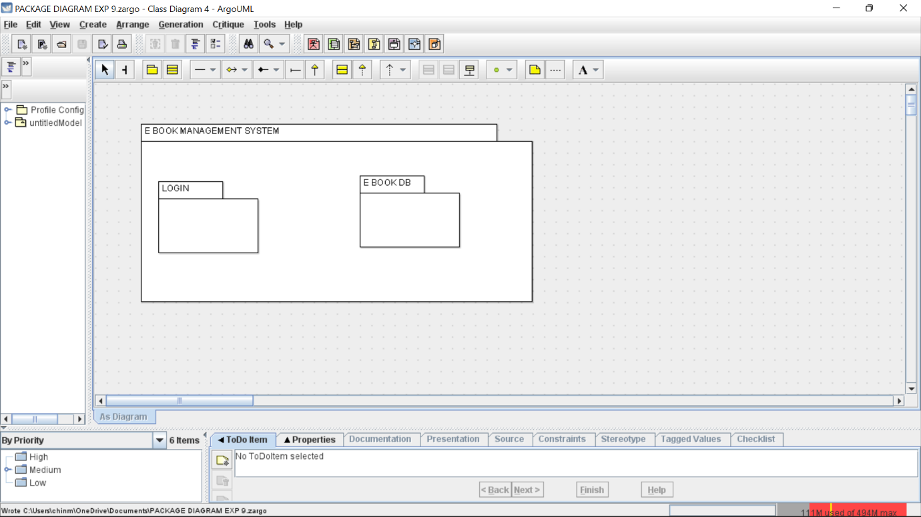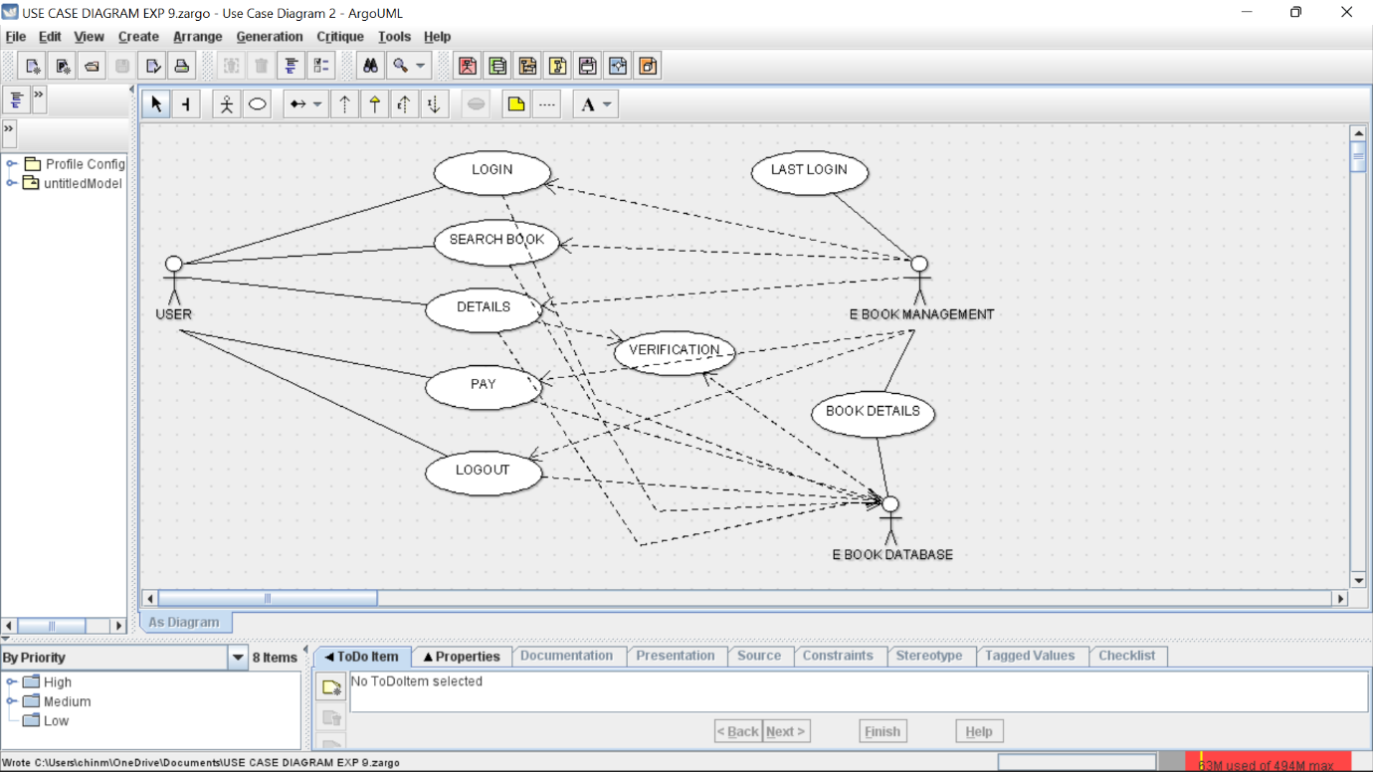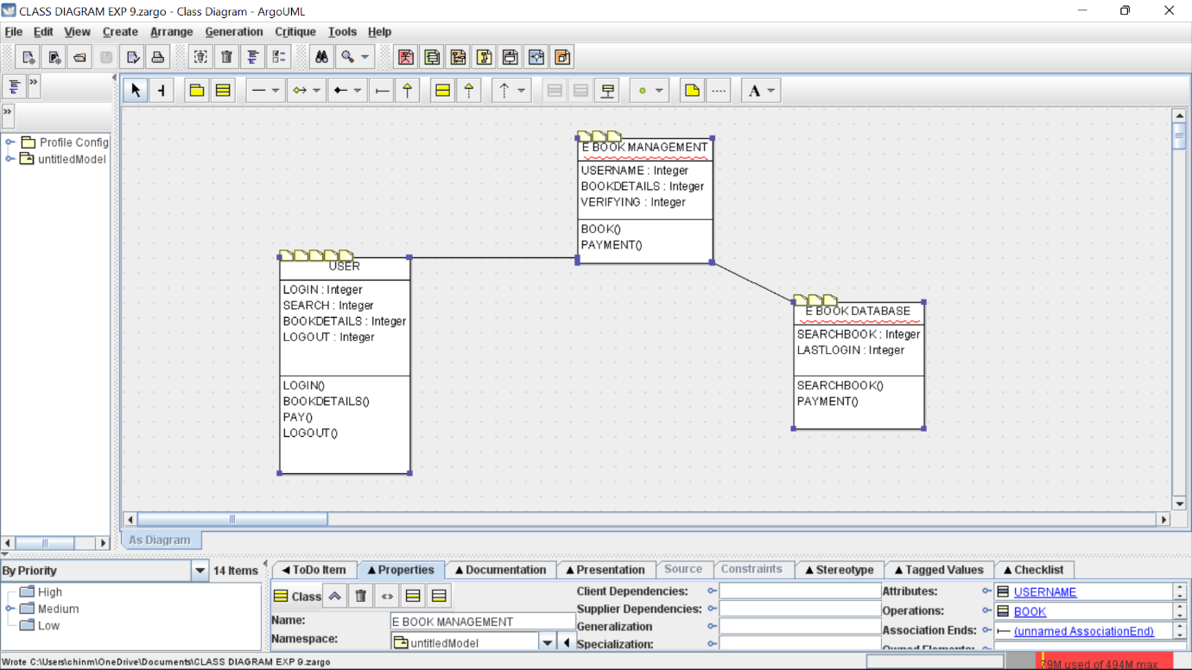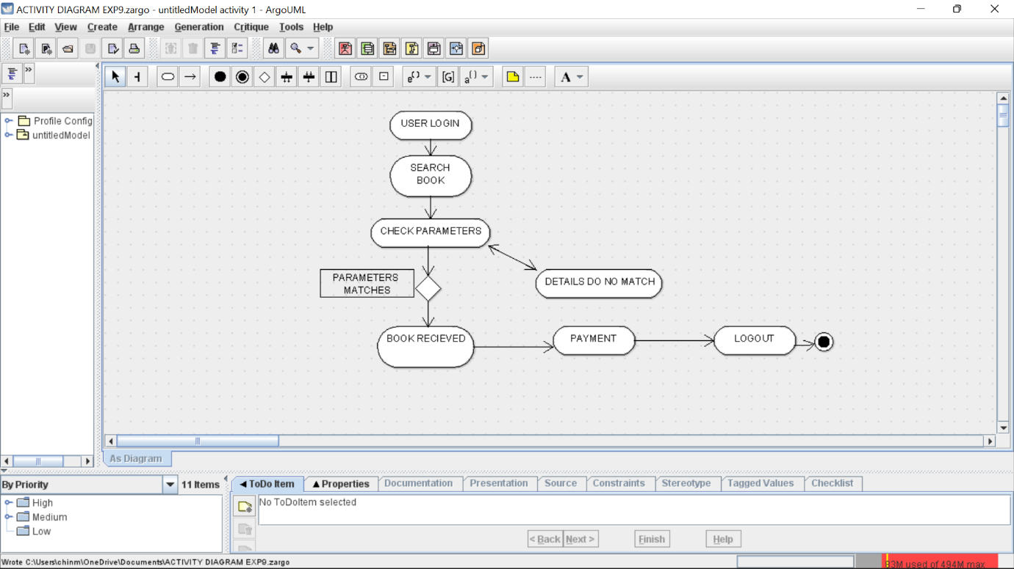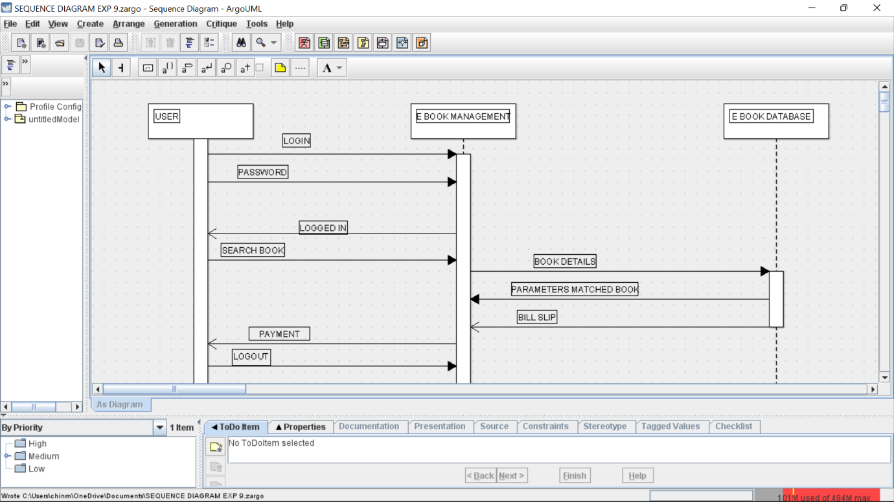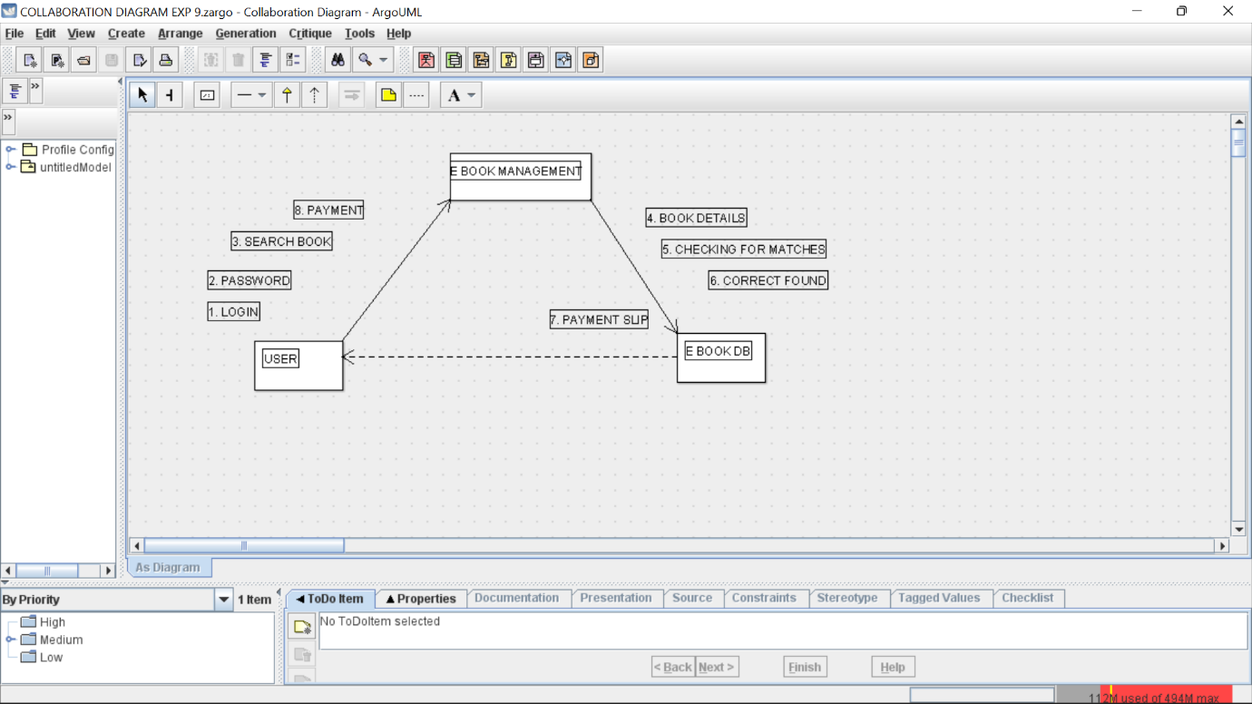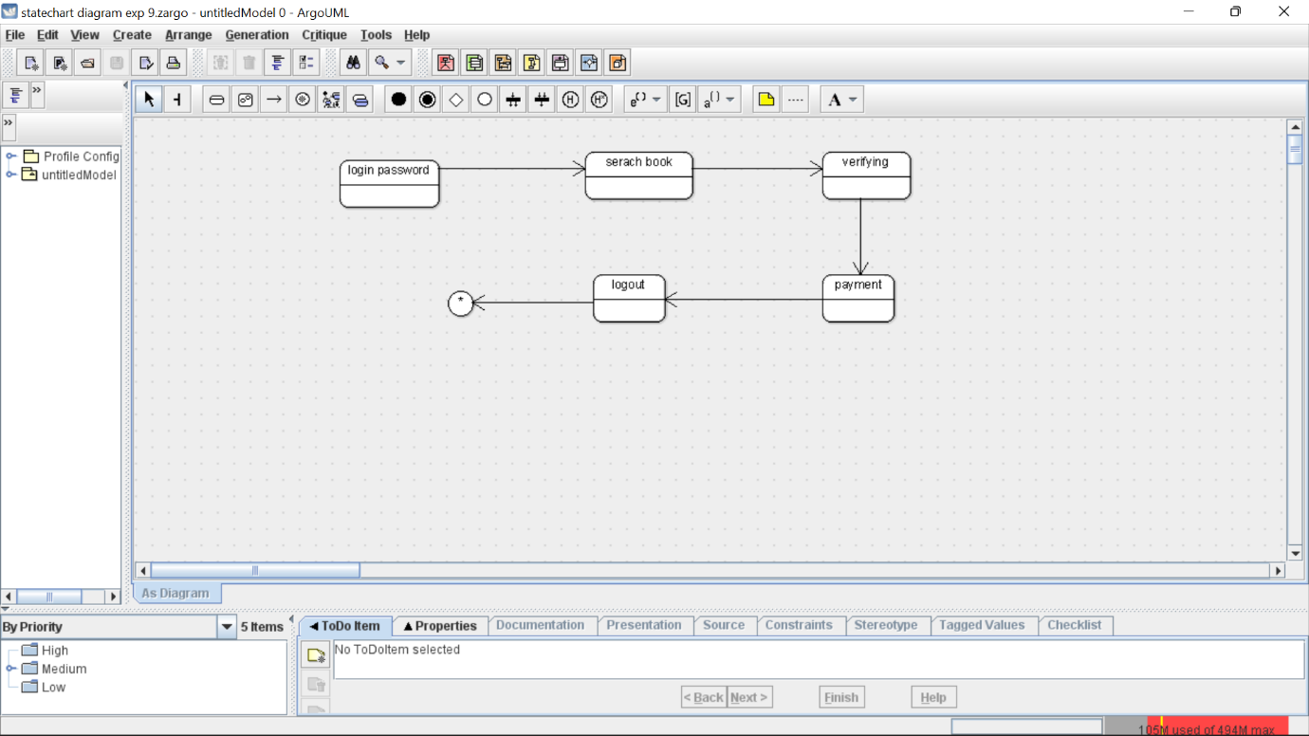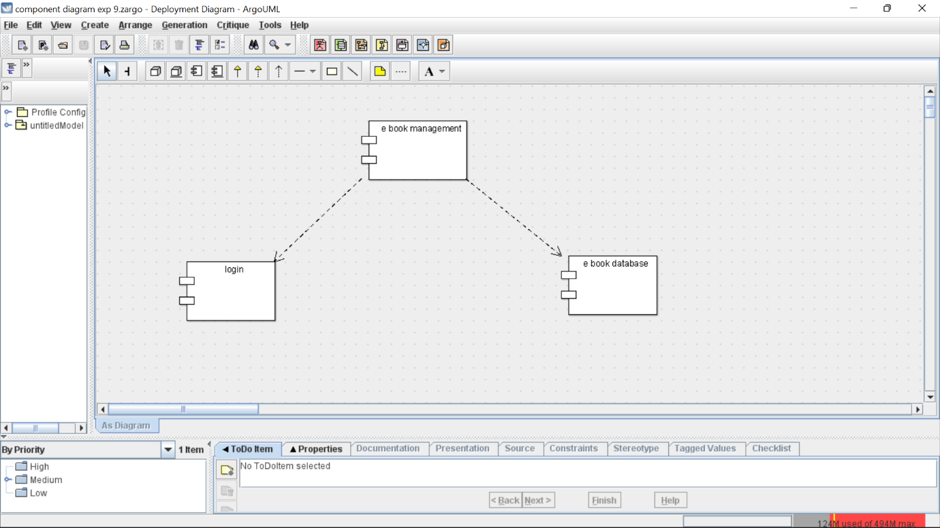

Skelwton code

import java.util.Vector;

public class E BOOK DATABASE {

public Integer SEARCHBOOK;

public Integer LASTLOGIN;

public Vector myE BOOK MANAGEMENT;

public void SEARCHBOOK() {

}

public void PAYMENT() {

}

}

import java.util.Vector;

public class E BOOK MANAGEMENT {

public Integer USERNAME;

public Integer BOOKDETAILS;

public Integer VERIFYING;

public Vector myUSER;

public Vector myE BOOK DATABASE;

private void BOOK() {

}

public void PAYMENT() {

}

}

import java.util.Vector;

public class USER {

public Integer LOGIN;

public Integer SEARCH;

public Integer BOOKDETAILS;

public Integer LOGOUT;

public Vector myE BOOK MANAGEMENT;

public void LOGIN() {

}

public void BOOKDETAILS() {

}

public void PAY() {

}

public void LOGOUT() {

}

}